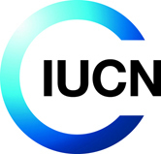

For Immediate Release (Embargoed until 21.05.2012)

Large dams in West Africa: building dialogue

Ouagadougou, Burkina Faso, 21.05.2012 (UICN-PACO) – Large dams have brought significant benefits in West Africa and are likely to provide more in the future. Providing electricity, improving irrigation, supplying drinking water are some of the benefits from large dams for communities in the region. Yet, the development of such infrastructures shouldn’t come at the expense of ecosystems and the people who depend on them. The implementation of large hydraulic structures requires careful consultation between all stakeholders involved. Lessons from such processes are explained and illustrated in a new publication produced by the IUCN West and Central Africa office.

The report, Regional Dialogue on large water infrastructure in West Africa: Building multi-stackeholder participation frome 2009 to 2011, is published by IUCN in partnership with the Water Resources Coordination Centre (WRCC) of Economic Community Of West African States (ECOWAS) It describes the various steps and progress of regional consultation, with the objective of contributing to the sustainable development of West African regional integration. The report also elaborates on the development of tools to support investment plans in a coordinated framework.

"It is necessary to learn from past experiences and find ways to minimize negative effects of large hydraulic infrastructures, in order to implement better processes in the future," says Mr Innocent Ouédraogo, Acting Director of the Water Resources Coordination Centre (WRCC/ECOWAS).

"IUCN is engaged in the international debate on dams and sharing of profits, especially through regional dialogue with ECOWAS. Its strategy is to strengthen the ongoing process of knowledge through research, support for the participation of all stakeholders, including civil society, and promoting good environmental and social practices to meet the challenges posed by the World Dams Commission", said Mr Ousmane Diallo, Water and Wetlands Regional Programme Coordinator of Central and West Africa IUCN Office.

As part of this regional dialogue, among others, the decision-making process during design and construction of three dams selected (Manantali in Mali, Kandadji in Niger and Bui in Ghana) were analyzed by a panel of independent experts. This analysis helped to define best practices and develop guidelines that have been shared and adjusted in consultation with States, basin organizations and civil society, and that will develop a framework directive across the region.

Download the publication

Pictures

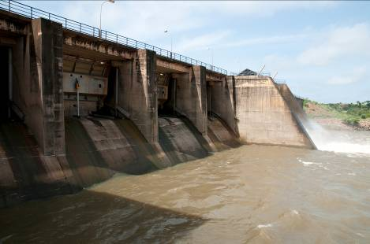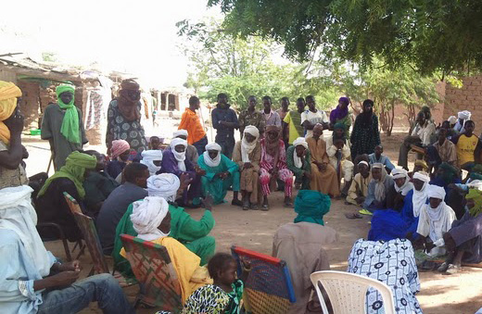

Contacts :

For more information or an interview, please contact:
Félicité MANGANG, Comunication Officer
IUCN – West and central Africa Programme (PACO)
Phone: +226 50 36 49 79, felicite.mangang@iucn.org
websites: http://iucn.org/paco - http://www.dialoguebarrages.org

Marcello ROCCA, Communication Officer - Water and Wetlands Regional Programme (PREZOH)
IUCN – West and central Africa Programme (PACO)
Tel: +226 50 36 49 79, marcello.rocca@iucn.org
websites: http://iucn.org/prezoh - http://www.dialoguebarrages.org

About IUCN

IUCN, the International Union for Conservation of Nature, helps the world find pragmatic solutions to our most pressing environment and development challenges by supporting scientific research; managing field projects all over the world; and bringing governments, NGOs, the UN, international conventions and companies together to develop policy, laws and best practices.

The world's oldest and largest global environmental network, IUCN is a democratic membership union with more than 1,000 government and NGO member organizations, and almost 11,000 volunteer scientists and experts in some 160 countries. IUCN's work is supported by over 1,000 professional staff in 60 offices and hundreds of partners in public, NGO and private sectors around the world. IUCN's headquarters are located in Gland, near Geneva, in Switzerland.

www.iucn.org/paco IUCN on Facebook IUCN on Twitter

