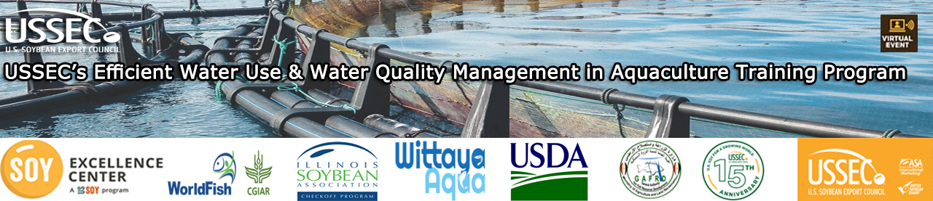
USSEC’s Efficient Water Use and Water Quality Management in Aquaculture Training Program
Wednesday, October 20th at 12:45 PM Cairo Time
Time | Sessions | Speakers
12:45 PM | Opening Welcome | WorldFish & USSEC
01:00 PM | Water Quality Management in Aquaculture | Dr. Diaa Kenawy
01:45 PM | Use of Aeration in Fish Ponds to Enhance Water Quality | Dr. Sherif Sadek
02:30 PM | Break
02:40 PM | Water Quality in IPRS | Dr. Skip Kemp
03:25 PM | Role of Feed Quality in Maintaining Optimal Pond Environment | Dr. Dominique Bureau
04:10 PM | Impact of Water Quality on Fish Health & Performance | Dr. Salah Meselhy
04:55 PM | Successful Fish Farming Tips, Techniques, and  Ideas to Avoid Common Mistakes | Dr. Diaa Al-Kenawy
05:05 PM | Open Discussion | All Participants
05:30 PM | Closing Remarks | WorldFish & USSEC

