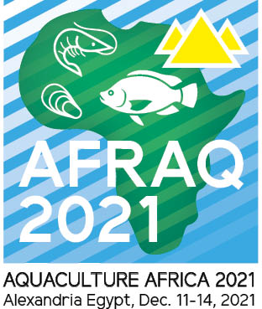

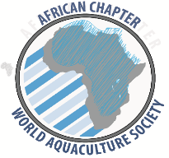

***13th October 2021***

**Aquaculture Africa 2021 (AFRAQ21) December 11 – 14, 2021 -**

**Last chance to submit an Abstract by 15 October!**

Having assessed the COVID-19 health and safety protocols in Egypt, approval by government and the convention centre (Alexandrina Bibliotheca), AFRAQ21 will go ahead as planned - **as an in-person event.**

WAS and AFRAQ21 Conference Management is cognizant of the need to hold the Conference under COVID-19 health and safety protocols as stipulated by the government of Egypt as well as the Bibliotheca Alexandrina, to ensure safety of Conference attendees.

Please note:

* Registration is open. Complete the online registration form on <https://www.was.org/Meeting/Registration/Submit/AFRAQ20>
* Submission of abstracts and full papers has now been extended to 15th October 2021. All abstracts already submitted are valid and will be processed accordingly. Visit <https://www.was.org/meeting/Abstract/Submit/AFRAQ20>
* Limited space is available for interested tradeshow exhibitors. Please contact: [mario@marevent.com](mailto:mario@marevent.com)
* We urge participants to get vaccinated to reduce COVID-19 risks.
* Should there be any changes, this will be communicated to all timeously.

We look forward to meeting you in Alexandria, Egypt in December 2021!

For more information and regular updates including the updated brochures, please visit website <https://www.was.org/meeting/code/AFRAQ20> . You are also welcome to contact us for further queries on [mario@marevent.com](mailto:mario@marevent.com) and [worldaqua@was.org](mailto:worldaqua@was.org) or [africanchapter@was.org](mailto:africanchapter@was.org)