International Institute for Environment and Development

Job Description

Job Title: Knowledge Management and Communications Coordinator, Global Water Initiative West Africa (GWI)
Reports to: Director GWI West Africa
Main purpose: Work with researchers, communications team and partners to better engage policy makers and other research users, particularly through producing a range of outputs to target multiple audiences
Main contacts: Internal: Director of Communications, Director GWI West Africa, GWI colleagues, IIED Researchers, communications team
External: GWI coordinator West Africa (Ouagadougou), Global GWI policy and advocacy coordinator (Atlanta), IIED’s partners and IIED’s key target audiences

Circumstances: Full time, permanent position, based at London office

Salary: Grade 3: £40,810 - £44,955, plus benefits according to experience, with up to £50,746 for exceptional candidates

Overview

The International Institute for Environment and Development (IIED) is a leader in the field of sustainable development. With over 100 staff based in London and partners around the world, IIED has been at the forefront of policy-making in development for nearly 40 years. IIED aims to provide expertise and leadership in researching and achieving sustainable development at national, regional and global levels. In alliance with others, the institute is working to end global poverty and deliver and sustain efficient and equitable management of the world’s resources.

IIED is not a campaigning organisation but does believe in taking a stronger advocacy stance than most research organisations. Our ability to influence thinking within the global policy-making community about the real implications of development decisions facing people on the ground, and our ability to communicate the voices of the local communities we work with is paramount. We are trying to make connections from local situations to global decisions, both through research and long-term partnerships.

Background to the Post

An experienced bilingual communicator is sought to play a leading role in delivering the GWI strategy. The postholder will work with IIED researchers and partners to influence and inform through writing that is lucid, to the point and best adapted to the needs of targeted readerships. Communication outputs are created in a variety of formats including: policy briefs, opinions, video scripts, web features and technical publications. It is important that these communication outputs be made available rapidly after the completion of field activities (workshops, research reports etc.). The role also involves gathering feedback from users of research outputs to assess impact. Audiences include educated generalists, other researchers in environment and development fields, technical experts, NGOs, and advisors and ministers in national environment, finance and development ministries and in local government. These may be either developed or less developed country-based.

The Natural Resources Group is one of the 4 research groups in IIED and aims to promote sustainable governance of natural resources by building capacity and promoting informed decision-making in communities in Africa, Asia and Latin America. The Natural Resources Group consists of 6 teams in Forestry, Agroecology, Biodiversity, China Strategy, Land Rights, and the Global Water Initiative (GWI).

The GWI is funded by the Howard G. Buffett Foundation and is a global partnership including IIED, IUCN, CARE and CRS. The purpose of the Initiative is to build evidence based advocacy programmes that empower smallholder farmers to use water more efficiently in three regions: Central America, East and West Africa. IIED leads a partnership with IUCN working in Burkina Faso, Mali, Niger, Guinea and Senegal that contributes to regional and national learning and policy change, while also feeding in to global advocacy programmes.

GWI has been running since 2007 and an initial website summarising learning and achievements of the first phase (2008-2012) has been designed (www.gwiwestafrica.org\en). In the second phase, which has a budget of $1.5M per year, much more emphasis is placed on communicating lessons, policy advice and GWI learning that requires reinforcement of the knowledge management and communication capacity of the GWI West Africa team.

The IIED communications team is a busy and friendly team of ten people, working with all other parts of the Institute. For IIED’s research to respond to the needs of decision makers and have an impact, it is essential that the institute has a strong communications capacity. The IIED communications team enhances the impact, influence and reach of IIED’s research and experiences, along with that of its partners. Through means such as publications and press work, but also using interactive processes such as web tools and events, the team’s aim is to present the research with integrity and force, and so influence key policy-makers and other audiences.

The GWI West Africa team includes country coordinators in each country, one regional coordinator based in Burkina Faso, two IIED staff members, partner institutes (IRAM, IWMI, IED Afrique) and the global team includes representatives of all participating partners (IUCN, CARE, CRS, IIED).

Our knowledge management and advocacy strategy can be expressed in two main objectives:

- To make sure our work is quickly and easily accessible, via clear content, good design and wide dissemination in French and English
- To understand and target different key audiences, both globally and in West Africa – policymakers, media, academics and the interested general public with appropriate materials to ensure IIED and its partners’ research can stimulate policy change;

The postholder will belong to the Natural Resources Group but will physically sit within the IIED communications team in London who will provide strategic support. The postholder will contribute to delivering the programme of the Global Water Initiative, linking with West African and Global colleagues through the core GWI team in IIED. The GWI team in the UK consists of:
- Jamie Skinner – Principal Researcher (Director GWI West Africa)
- Barbara Adolph – Principal Researcher (Agroecology Team Leader)
- Geraldine Galvaing - Coordinator (Agroecology and GWI)
- Vacancy – Knowledge Management and Communications Coordinator

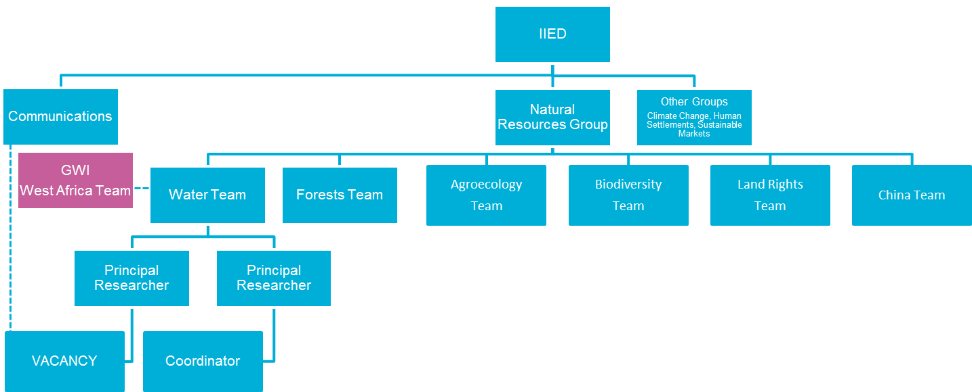

Key Responsibilities

Knowledge Management & Communications (90%)
- Synthesise research outputs from IIED and IUCN staff into a variety of formats designed to communicate to multiple audiences - from policy briefings to short reports and booklets etc.
- In collaboration with partners develop similar outputs, as necessary.
- Identify potential users of GWI research outputs and develop an understanding of their interests, capacities and preferences.
- Develop an engagement strategy with the GWI team that will be effective in responding to the needs and interests of research users.
- Write features/comments/articles in national and international mainstream media as well as in more specialist media.
- Deliver advocacy and communications materials in collaboration with GWI colleagues in the Global Policy and Advocacy team for international meetings and the web.
- Work with external proof readers, translators, layout staff, printers and editors on relevant outputs.
- Maintain the bilingual GWI website (www.gwiwestafrica.org) ensuring complementarity with sister site for ECOWAS www.dialoguebarrages.net), and posting regular updates and materials.
- Build and maintain a photo library using the current IIED platform.
- Develop and produce evidence based outputs and publications in two languages (French/English).
- Undertake short translations as appropriate.
- Travel internationally to events, workshops or particular projects in order to develop stories and represent GWI when needed.
- Participate in communications team activities and planning with responsibility for ensuring good liaison between the GWI team and the communications team.

Finance and Administration (10%)
- Work with GWI Coordinator on all financial and reporting aspects of GWI work
- Contribute to donor reporting as required
- Monitor budget lines associated with outputs
- Monitor and evaluate the impact of the research outputs by gathering feedback from users
- Manage personal administrative tasks related to own work.

This job description defines the level of responsibility and areas of involvement of the post; the details of the duties may change over time and do not form part of the contract between IIED and the post holder.

Person Specification

- Essential requirements

Academic and professional qualifications

- Post graduate qualification in a relevant discipline e.g. communications, journalism, environment & development.

Relevant experience

- Substantial relevant work experience, including work as a researcher or working closely with researchers and / or work either as a journalist or alongside journalists.
- Proven experience of acquiring, analysing and synthesising research for a variety of audiences in a way that maximises understanding while retaining the central integrity of the evidence contained in the research findings.
- Demonstrable understanding of the local context including key actors such as policy makers at national and international level as well as researchers and donors.
- A thorough understanding of environment and sustainable development issues and a demonstrable understanding of policy-oriented research and/or advocacy.
- An established reputation and publications record.
- A good understanding of communication strategies including how to target different audiences through communications and research uptake theory and practice.
- Experience of working with a range of communications channels or media – print, digital, social media.
- Lively interest in developments in communications technologies.
- Experience of managing and monitoring budgets.
- Experience of monitoring and evaluating outputs.
- Willingness and ability to travel internationally as appropriate to project commitments.

Key skills

- Bilingual in French and English (verbal and written).
- Excellent written communication skills in both languages, a demonstrable commitment to quality editing and an ability to write for different audiences.
- Ability to work independently and collaboratively as a member of multi-disciplinary teams, including internal, external and international.
- Strong interpersonal, networking and negotiation skills developed through interacting with people from different backgrounds and culture.
- Ability to manage own workload and to work to tight deadlines without close supervision.
- Good working knowledge of Windows-based computing, including word-processing (Word) and spreadsheets (Excel).

- Desirable requirements

- Experience in the advocacy policy campaigning environment.
- Experience of working in an international context.
- Work experience in less developed countries.
- Knowledge of Desk-top Publishing (DTP) packages such as Adobe InDesign.
- Experience with website content and management.

