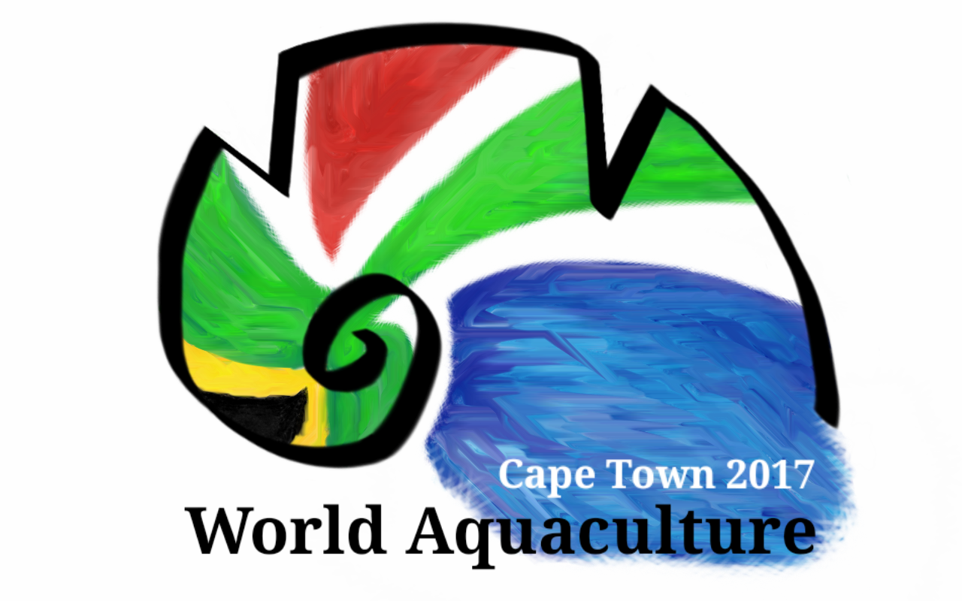

World Aquaculture 2017

Sustainable Aquaculture
New Frontiers for Economic Growth-
Spotlight on AFRICA

June 26-30, 2017
Cape Town ICC
Cape Town
South Africa

To Whom it may Concern 21 October 2016

RE: Name organisation + contact person

INVITATION TO ATTEND WORLD AQUACULTURE 2017 (WA 17) – 26 – 30 June 2017,
IN CAPE TOWN, SOUTH AFRICA

On behalf of Aquaculture Association of Southern Africa and the World Aquaculture Society, and in collaboration with Department of Agriculture, Forestry and Fisheries (DAFF) and African Union Interafrican Bureau for Animal Resources (AU-IBAR), we are pleased to invite you to attend WORLD AQUACULTURE 2017. The meeting will be held from June 26-30, 2017, at the Cape Town International Convention Centre, South Africa. During this meeting, the formation of an African Chapter of the World Aquaculture Society (WAS) will be discussed and your participation in this important initiative is vital.

WORLD AQUACULTURE 2017 will feature technical sessions and workshops covering nearly all aspects of aquaculture around the world. There will be international professionals in attendance to present the latest research and investigations on technical and practical aspects of aquaculture. WA 17 will also feature a trade show, where all the biggest names in aquaculture will be advertising and displaying their latest equipment, feed, software etc.

Please submit your abstract online: www.was.org (click WA17 logo) before February 1, 2017.

A reduced registration fee for all African Aquaculture delegates to attend WORLD AQUACULTURE 2017 has been negotiated with WAS for all African delegates who register in advance.

The Reduced prices for African delegates if online registration before May 26th:
- Students at 150 USD
- Attendees at 300 USD

Registration fee for African delegates who register after May 26th
- Students at 200 USD
- Attendees at 475 USD

All African associations are invited to hold their annual meeting prior/during the WA17 event in Cape Town. For more information please check www.was.org or contact mario@marevent.com.

It is our sincere hope that you will be able to attend WORLD AQUACULTURE 2017.

We would like to point out that WORLD AQUACULTURE 2017 is not responsible for any travel expenses including airfare, lodging, ground transportation, meals, conference registration, and any other incidentals.

Please also note that you must apply early for your VISA if you require one, as it sometimes takes a number of weeks.

We look forward to seeing you in Cape Town

Yours faithfully
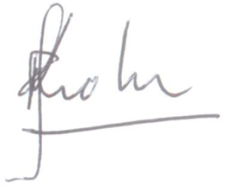
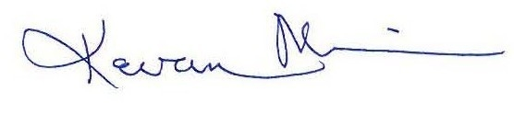

Roger Krohn Kevan Main
AASA Chairman WAS Chairman

