University of Stirling
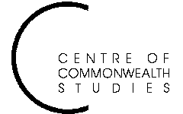

Colonial and

Postcolonial Studies
Seminars

Tuesday 26 April at 6 pm

in Pathfoot A7

Indrajit Hazra
Charles Wallace India Trust Fellow, University of Stirling

‘No genre please – aren’t we Indian?’

ALL WELCOME TO ATTEND
For further details, contact Prof. Angela Smith on a.m.smith@stir.ac.uk or 01786 467503

