University of Stirling
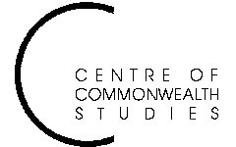

Colonial and

Postcolonial Studies
Seminars

Spring Semester 2004

Tuesday 2 March at 5:15pm in Pathfoot A7:

New Critical Forum: Theory, Politics, Postcolonialism
9/11 Theory

Tuesday 9 March at 5:15 pm in Pathfoot A7:

SHEEKUMAR VARMA

The Charles Wallace Trust Fellow for 2004 will give
a reading from his own fiction

Monday 15 March at 5:15 pm in Pathfoot A7 (not the usual Tuesday):

DR ANANYA JAHANARA KABIR, University of Leeds
‘Representing Kashmir: Bollywood and Beyond’

Tuesday 30 March at 5:15 pm in Pathfoot A7:

New Critical Forum: Theory, Politics, Postcolonialism
Refugees and Asylum: the Question of ‘Hospitality’

Tuesday 20 April 5:15 pm in Pathfoot A7:
Joint seminar with the Department of History

DR RICHARD REID, University of Durham

For further information please contact Professor Angela Smith: tel 01786 467503 or
e-mail ams1@stir.ac.uk
If you wish to be on the CCWS email directory please send your email address to suzy.dryburgh@stir.ac.uk.

