University of Stirling
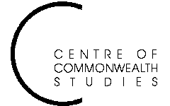

Colonial and

Postcolonial Studies
Seminars

WEDNESDAY 14 November at

4 pm in Pathfoot A7, jointly with English Studies

Dr Bill Schwarz
Queen Mary College, University of London
We have met before. The West Indian literary imagination at the time of declonization

ALL WELCOME TO ATTEND
For further details, contact Prof. Angela Smith on a.m.smith@stir.ac.uk or 01786 467503

