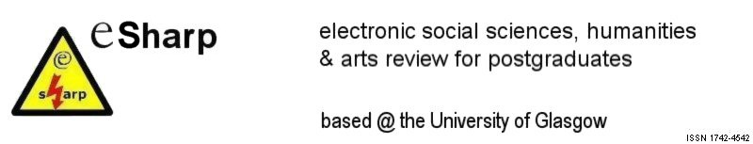

CALL FOR PAPERS

eSharp is the online journal for social sciences, arts and humanities postgraduates based at the University of Glasgow. It is a peer-reviewed journal that aims to provide a critical but supportive entry into the world of academic publishing.
Our latest issue, on ‘Journeys of Discovery’, has recently been published at www.sharp.arts.gla.ac.uk and we are now looking for submissions for the sixth edition to be launched in Autumn 2005. We welcome papers from postgraduates working in all areas.
The theme of the sixth edition is

Identity and Marginality
Topics may include but are not limited to:

- Political Representation
- Self and Other
- Minorities
- The Ego
- Nationalism
- Regionalism
- Globalisation
- (Post-)Colonialism
- Migration, Diaspora and Exile
- Psychoanalysis
- Race and Ethnicity
- Otherness
- Dialogue and Conflict
- Asylum
- Crossing Cultures
- Childhood/Adult Development
- Abjection
- Space
- Self-discovery
- Repression and Dominance
- Collectivism
- Religion
- Media analysis
- Body and Gender
- Expulsion

Articles (word limit 4500-5000 words) must be submitted by 25 July 2005. Please ensure that you accompany your submission with an abstract of 200-250 words and a list of 3-5 keywords for meta-tagging. For a full list of guidelines and our style sheet please see www.sharp.arts.gla.ac.uk.
Please submit your article (both abstract and full paper) to sharp@arts.gla.ac.uk.

