University of Stirling
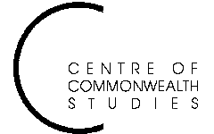

Colonial and

Postcolonial Studies
Seminars

and the Department of English Studies

Tuesday 9 March at 5.15pm

in Pathfoot A7

Shreekumar Varma
Charles Wallace India Trust Fellow
will read from his own work

ALL WELCOME TO ATTEND
For further details, contact Prof. Angela Smith on a.m.smith@stir.ac.uk or 01786 467503

