University of Stirling
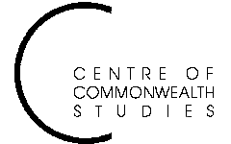

Colonial and

Postcolonial Studies
Seminars

Monday (not the usual Tuesday) 15 March at 5.15pm

in Pathfoot A7

Dr Ananya Jahanara Kabir
University of Leeds

‘Representing Kashmir: Bollywood and Beyond’

ALL WELCOME TO ATTEND
For further details, contact Prof. Angela Smith on a.m.smith@stir.ac.uk or 01786 467503

