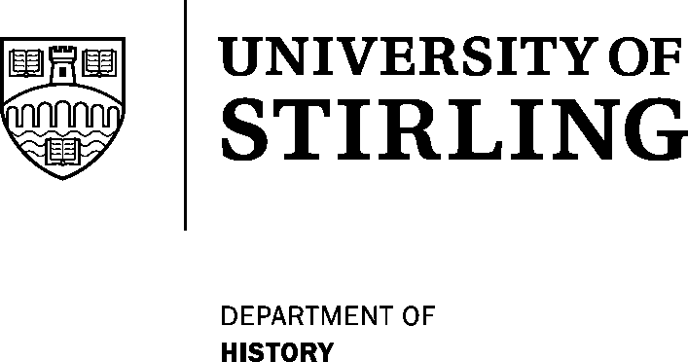
THE CENTRE FOR RESEARCH IN POLISH HISTORY

Director : Professor Peter D Stachura, Professor of Modern European History

University of Stirling, Stirling FK9 4LA, Scotland, UK.
tel: 01786 467580/85 fax: 01786 467581 e-mail: p.d.stachura@stir.ac.uk

THE GENERAL W. ANDERS MEMORIAL POSTGRADUATE SCHOLARSHIP

IN POLISH HISTORY

The Centre for Research in Polish History invites applications for this prestigious award from graduates who wish to pursue postgraduate research on any aspect of Polish history. Applicants should have or anticipate having at least a very good Upper Second Class Honours degree in History or a related discipline.

The award, which is sponsored annually by the M. B. Grabowski Fund, commences in September 2005 under the supervision of Professor Peter D. Stachura at the University of Stirling, and is designed to cover, wholly or in part, the fees payable to the University for one year’s full-time tuition (or equivalent).

Candidates should provide a letter of application, curriculum vitae, a synopsis of the proposed research topic, and the names and addresses of two academic referees.

Proficiency in Polish language is not usually necessary for Master’s level but is a requirement for doctoral candidates. Language instruction can be arranged.

Applications must be submitted no later than 18 May 2005 to Professor Stachura at the address given above. Candidates should also complete at the same time a University of Stirling postgraduate application form obtainable from the Secretary, Faculty of Arts Office, Pathfoot Building, University of Stirling, Stirling, FK9 4LA.

--------------------------------------------

General Wladyslaw Anders (1892-1970) was one of the most successful and revered Polish Army leaders of the Second World War, and from enforced exile in London after 1945 he also emerged as one of the staunchest advocates of the cause of a free and independent Poland.
-------------------------

