University of Stirling
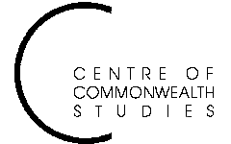

Colonial and

Postcolonial Studies
Seminars

and the Department of History

Tuesday 20 April at 5.15pm

in Pathfoot A7

Dr Richard Reid
University of Durham

‘States, Rebels, Bandits: modes of conflict in
nineteenth–century eastern Africa’

ALL WELCOME TO ATTEND
For further details, contact Prof. Angela Smith on a.m.smith@stir.ac.uk or 01786 467503

