Dear All
You are invited to the first Open Psychology Research Centre (OPRC) public online lecture of the 25/26. The first talk will be delivered by Prof Catriona Havard, Co-Director of OPRC and details are below.
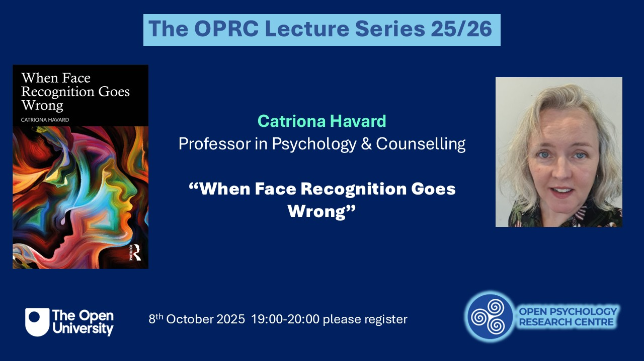

Catriona Havard, Professor of Psychology at the Open University, presents an intriguing exploration of the myriad ways that humans and machines make mistakes in facial recognition. Her work with police forces throughout the UK has shown how errors in recognising faces, including eyewitness identification in police lineups, can lead to miscarriages of justice. She will present an interactive, illustrated talk based on her ground-breaking new book 'When Face Recognition Goes Wrong' featuring personal anecdotes, real-world examples of everyday social interactions, problems with border control passport verification, and the near-future dangers of increasing live face recognition technology.
To register for the talk please visit https://events.teams.microsoft.com/event/656278b7-2019-476b-bf9a-2f9d3650199c@0e2ed455-96af-4100-bed3-a8e5fd981685

