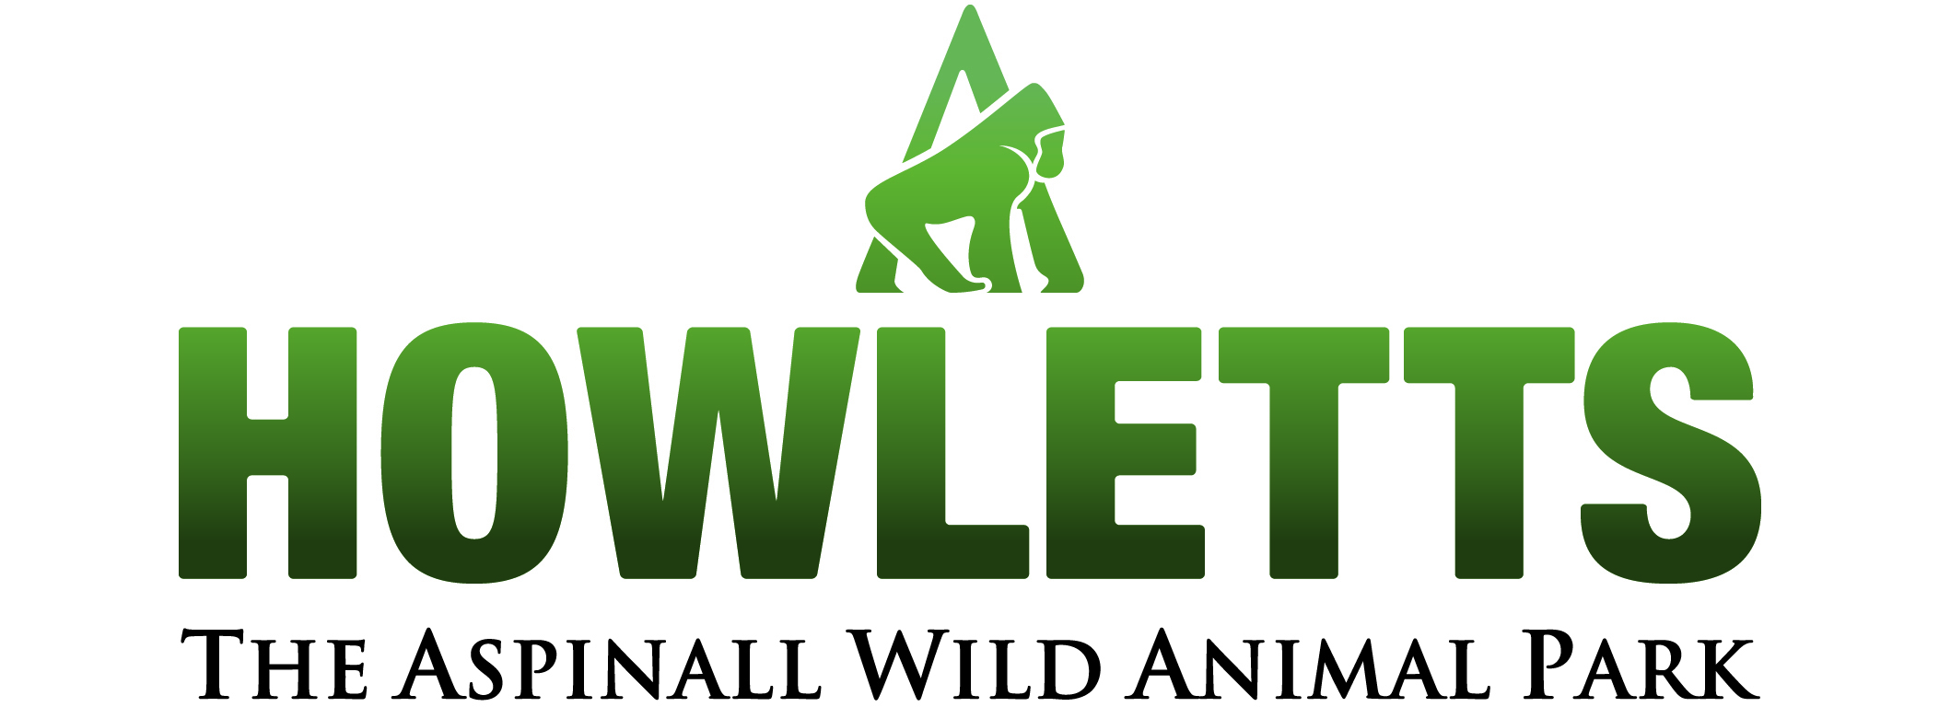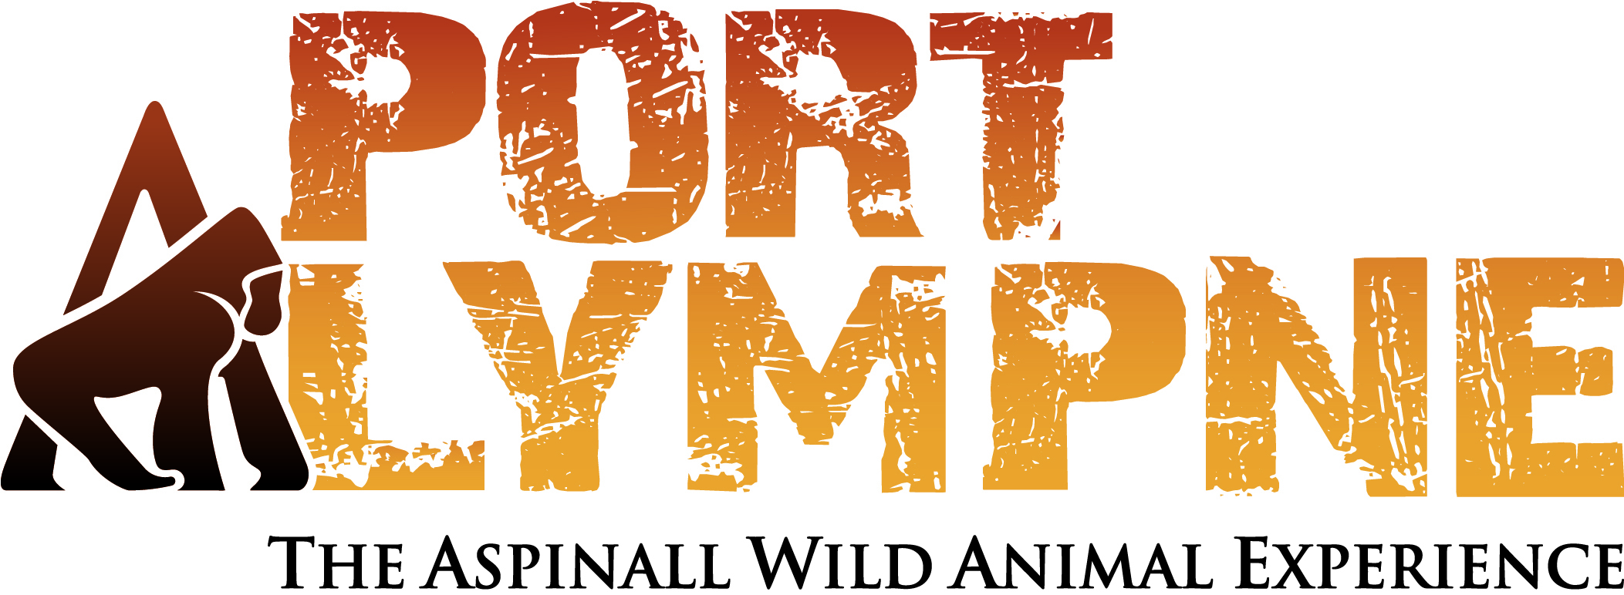

The Second Howletts and Port Lympne Student Environmental Enrichment Course (SEEC), 20th – 23rd April 2010

Instructor: Mark Kingston Jones

Due to the high demand for places and positive feedback, Howletts and Port Lympne Wild Animal Parks are pleased to announce their second course on Environmental Enrichment to be run by Mark Kingston Jones in collaboration with keepers from both institutions. Mark has been involved in the animal welfare field since 2004. He now works at Howletts and Port Lympne as ‘Enrichment and Research Officer’, organising workshops, talks and working with keepers to design and implement enrichment ideas. In addition to co-running the first SEEC, he has been involved in two ‘The Shape of Enrichment’ workshops, in the UK and Indonesia and is now the Shape-UK & Ireland events co-ordinator. As well as receiving two animal welfare awards for student research projects, he has presented 9 talks on topics relating to animal welfare at conferences, both nationally and internationally.

This course is designed specifically for college and university students (past or present) who do not currently work within a zoo setting, but are looking to do so as a career. Over 3.5 days students will gain a background in animal welfare and enrichment, dealing with welfare needs of different species, as well as providing practical skills in designing, building and testing enrichment within the settings of both Howletts and Port Lympne Wild Animal Parks, in Kent. Our aim is to provide valuable experience and an overview of additional useful skills to a would-be keeper’s CV. Please note you must be 18 or over to attend this course.

This course is roughly split equally between lecture and practical components. Lecture topics include: Animal welfare, the 5 categories of enrichment, the enrichment framework, animal husbandry and learning, enclosure design and breaking into the zoo world. Additionally there will be keeper lead talks and practicals involving working with carnivores, primates, ungulates, elephant management, in-situ conservation, rope splicing and fire hose weaving. The final day of the course will result in the application of all these principles as delegates are split into groups allowing you the opportunity to design, build and test enrichment with one of our animals from a selection of species.

Please note that delegates are required to provide their own lunches and can either bring their own or purchase food from the canteen. Information on discounted accommodation including dinner, bed and breakfast is available on request and the number of available places is limited, so please book early.

The workshop registration fee of £150 includes:
All workshop materials over the 3.5 days
Practical sessions
Drinks and snacks during the scheduled tea breaks

For further information and to request a booking form please contact: Christine Dutfield on: intern@totallywild.net

Final deadline for registration is now the 11.4.10

