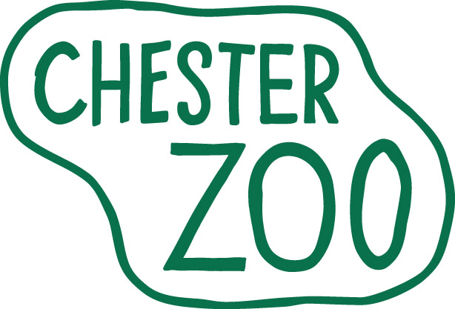

ONE YEAR INTERNSHIP (ANIMAL HUSBANDRY)
September 2017 – September 2018

The North of England Zoological Society (Chester Zoo) is one of the leading zoological collections in Europe with an international reputation for achieving its mission in conservation breeding programmes, research and education.
We are looking for highly committed, motivated individuals to join our animal husbandry departments for 12 month work experience/internship placements within this unique scientific/conservation environment. These Internships are practical in nature with a theoretical input but they are not designed to be ‘research’ placements as such.

These placements are demanding but highly rewarding voluntary positions and many of our past interns have gone on to follow careers in zoos.

The Internships:

- Maximum eleven months duration (plus four weeks holiday), commencing on Monday 11 September 2017 and finishing August/September 2018.

- Interns will be assigned to one of our animal keeping sections specialising in either birds; mammals; reptiles, amphibians and invertebrates, or fish and aquatic invertebrates.

- In addition to animal husbandry duties, interns will be required to spend at least 2 weeks assisting with the production and distribution of animal feeds (including management of invertebrate colonies, forage production, browse provision etc). There may also be opportunities to assist zoo staff with collection of behavioural and clinical data and involvement in environmental enrichment programmes.

- A limited number of places may provide the opportunity to combine the Internship with a ‘Sandwich Year’ of a University Course. If applicable to you, please ensure this is made clear in Section 4 of your application form.

- Interns will receive on-the-job training in the husbandry of the species with which they work, and a series of monthly ‘Workshops’ are arranged to teach other animal management topics including the basics of nutrition, collection planning, breeding programmes, in-situ conservation programmes, record keeping, enrichment etc.

- This is a full time and physically demanding position. Hours of work are from 7.00am to 4.00pm (birds) or 8.00am to 5.00pm daily, working ten days in fourteen, including alternate weekends, bank holidays etc as rostered.

As we are a Registered Charity, funded entirely by visitor fees and donations, we regret we are unable to offer any wages or salary for the placement. We will provide a full uniform and luncheon vouchers for the days that you attend. No other financial benefits are offered. However, we do offer a comprehensive practical training which together with the monthly ‘Workshops’ covering a wide range of subjects, provides significant insight into the functioning of a successful and responsible zoological collection, the aim being to promote your future employability.

What we are looking for in our interns:

- You must currently be studying for, or have completed, a broadly animal science related course at HND or Degree level or Level 4 NVQ.
- You must have a genuine interest in all aspects of animal husbandry and be empathetic to the mission of the Zoo
- You must be able to work as an individual or as part of a team, with a reliable and conscientious attitude and good communication skills.
- Have the ability to financially support and motivate yourself for the entire length of the internship.

Interested?
Application forms can be obtained from the Chester Zoo Website www.chesterzoo.org. Please ensure you use the One Year Internship Application Form and return it by post FAO ‘Penny Rudd’, The North of England Zoological Society, Cedar House, Caughall Road, Upton-by-Chester, CHESTER, CH2 1LH. For urgent and genuine queries only please contact Penny Rudd, Internships Co-ordinator via email at PennyR@chesterzoo.org. Interviews will be held for these positions in April and May 2017. Applicants from outside the UK will be offered Skype interviews but would be expected to fund their own travel and relocation costs if successful. Closing date: Friday 14 April 2017.

