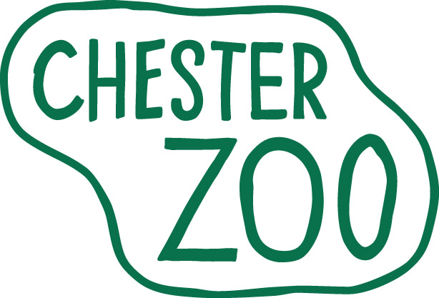
APPLICATION FOR A 1 YEAR INTERNSHIP

Conserving bio-diversity worldwide
PLEASE COMPLETE IN FULL AND IN BLOCK CAPITALS.
Personal Details
Title: Mr Mrs Miss Ms Other: | Address
First Name(s)
Surname/ Family name
Email:
Telephone (home) | Post Code
(mobile)
Term Time Address (if applicable)
 | Postcode
Vacancy Details
Position Applied for
Where did you learn of this vacancy?
Have you worked at Chester Zoo before? | Yes No Department
Educational & Professional Qualifications
Secondary & Further Education
Schools/Colleges/Universities attended (with dates) | Subject | Level | Grade | Date attained
Professional Qualifications
Schools/Colleges/Universities attended (with dates) | Subject | Level | Grade | Date attained
The Internship
1. We are interested to know your views on the role Zoos play in conservation. Are Zoos real players in conservation? Please answer this question and explain your thinking:
2. What do you think are the most important aspects of animal husbandry in a zoo setting?
3. What is the best team you have worked with and why?
4. How do you feel this internship will assist you with your future career? (If your internship would form part of your university degree, e.g. as a ‘sandwich’ placement, please provide details of this here, and please include a copy of your course requirements relating to the sandwich placement, with your application)
5. This internship is a full time, unpaid position. Please give details of how you intend to support yourself during this placement:
6. Rank the species/team which you would most like to work with on a scale of 1 – 11 (1= high,11 = low)

Section/species | Ranking | Section/species | Ranking
Hoof stock & Rhinos |  | Elephants
Hoof stock & Giraffes |  | Primates
Carnivores |  | Parrots & Penguins
Small Mammals |  | Other bird species
Animal food provision  (including invertebrate management). |  | Herpetology, including Butterflies
Animal food provision  (including invertebrate management). |  | Aquarium
Explain the reasons behind your top 3 Choices:

Reference Details
Please provide two employment referees, one of which must be your most recent employer. If you have not worked previously, please provide details of professional referees (not relatives) as appropriate e.g. school/academic tutor. You should be aware that we will not approach your referees without your permission.
Name of referee | Name of referee
Address | Address
Post Code | Post Code
Telephone Number | Telephone Number
Fax Number | Fax Number
Email address | Email address
Rehabilitation of Offenders Act 1974 and Zoo Licensing requirement
Have you ever been convicted of a criminal offence which has not been ‘spent’ under the Rehabilitation of Offenders Act 1974? Yes No
Can you comply with Zoo Licensing requirements as shown below? Yes No
Requirements for working at a Zoo
Under the Zoo Licensing Act, a Zoo may lose its license should it employ or engage a person who has been convicted of any offence under the following Acts:
the Protection of Animals Acts 1911 to 1964
the Protection of Animals (Amendment) Act 1988
the Protection of Animals (Amendment) Act 2000
the Protection of Animals (Scotland) Acts 1912 to 1964
the Pet Animals Act 1951
the Protection of Birds Acts 1954 to 1967
the Animal Boarding Establishments Acts 1963
the Riding Establishments Acts 1964 and 1970
the Breeding of Dogs Act 1973
the Animals Act 1971
the Conservation of Wild Creatures and Wild Plants Act 1975
the Dangerous Wild Animals Act 1976
the Wildlife and Countryside Act 1981
the Endangered Species (Import and Export) Act 1976
the Control of Trade in Endangered Species (Enforcement) regulations 1997
A person working within the Zoo whose conviction for an offence under any of the above Acts, or any other Act, would place NEZS (Chester Zoo) in jeopardy of prosecution for continuing to engage him or her. Applicants are required to declare their ability to comply with the appropriate legislation.
Under The Employment Equality (Age) Regulations 2006 where a person is older than, or within six months of, the employer’s normal retirement age, there is a specific exemption allowing employers to refuse to recruit that person. Our retirement age is 65.

Data protection
Information from this application may be processed for purposes registered by the Employer under the Data Protection Act 1998. Individuals have, on written request [on payment of a fee] the right of access to personal data held about them.
I hereby give my consent to Chester Zoo processing the data supplied in this application form for the purpose of recruitment and selection.
Declaration: To the best of my knowledge, the information given on this form is correct.

Signed Date

Please return this form to: PennyR@chesterzoo.org or by post to Penny Rudd, Registrar and Internships Coordinator, The North of England Zoological Society, Cedar House, Caughall Road, Upton-by-Chester, CHESTER, CH2 1LH.

