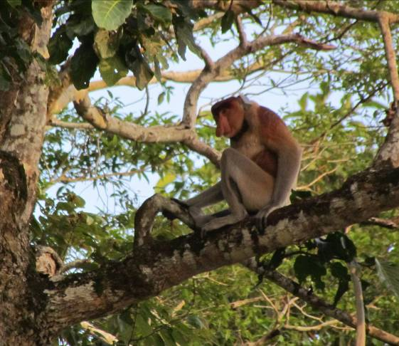
Methods and Techniques in Primate Behaviour and Ecology
Danau Girang Field Centre
Instructor:
Danica J. Stark
MSc Primate Conservation
Phone: +60 128 266 840
E-mail: danicastark@gmail.com

Course Description
The purpose of this course is to introduce the student to basic field methods and concepts in primate behavior and ecology. In addition, students will learn how to solve common problems associated with working in tropical forest ecosystems. The course consists of lectures/seminars, student presentations, field exercises, and group projects.
Lectures/Readings
There will be lectures on ecological concepts, primate ecology, primate behaviour, field techniques, behavioural sampling techniques, and analytical tools. Readings corresponding to lecture topics will be assigned from selected papers.
Required Textbooks:
- Martin, P. and Bateson, P. 1994. Measuring Behavior: An Introductory Guide. Cambridge University Press, New York.
- Campbell, C.J., Fuentes, A.F., MacKinnon, K.C., Panger, M. and Bearder, S. (Eds.). 2007. Primates in Perspective. Oxford University Press. 752p.
Field Exercises:
Students will learn the following field techniques, which will assist them in setting up their own independent field projects:
- Techniques in Satellite and Radio-tracking for diurnal and nocturnal primates
- Constructing habitat and phenology profiles
- GPS exercise
- Behavioural observations (behavioural sampling techniques)
- Parasite Analysis
- Primate Census Techniques (River, Forest Transects, Triangulation)
- Acoustics
Individual Research Projects:
With the assistance of the instructor, students will join up in groups of 2 or 3 and develop and carry out their own field project on a topic of their choice. Each topic must be approved by the instructor prior to beginning data collection. Each group will be required to write a research proposal, collect and analyse their data, and present their findings to the group on the final day at the Centre.
Tentative Course Schedule
- Day 1 Pick-up at Sandakan Airport. Arrive at the station via pre-arranged bus and boat ride from Sandakan as a group
- Day 2 Orientation with the station and trail system. Lectures begin.
- Day 3-8 Start of field exercises and introduction to field and project methods.
- Day 9-14 Individual research projects, writing up of research proposals. Lectures continue. Final presentation of individual projects on last day.
- Day 15 Drop-off at Sandakan Airport, via pre-arranged bus and boat from the Field Station

Formal Lecture Topics
- Primate Taxonomy and Distribution
- Ecological Principles
- Feeding Adaptations and Foraging Strategies
- Reproductive Strategies and Sexual Selection
- Social Organization and Ranging Patterns
- Primate Conservation
The students also have the opportunity to participate in other studies and projects going on at the field centre throughout the course of the program, which may include: camera trapping, amphibian surveys, small-mammal trapping, and crocodile tracking with radio-telemetry and satellite.
Please contact the instructor for more details.
