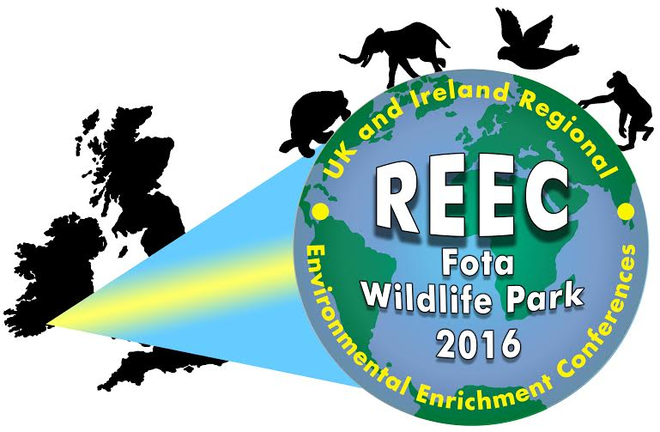

6th UK and Ireland Regional Environmental Enrichment Conference

Fota Wildlife Park
Sunday 22nd to Wednesday 25th May 2016

ABSTRACT SUBMISSION

CALL FOR PAPERS
Organisers invite the submission of abstracts for the Regional Environmental Enrichment Conference, for both oral and poster presentations. Oral presentations should be 15 minutes long, including time for questions. Abstracts will be reviewed by at least two referees and it is anticipated that authors will be notified of the outcome of their submission by Monday 4th April. It is highly advised that delegates register for the conference as early as possible to reserve their place as places are subject to availability. Registration for this conference will open soon; please check the websites below for updates or the Shape of Enrichment Facebook page.
http://www.enrichment.org/index.php
http://www.biaza.org.uk/public-events/

Organiser:
Eibhlín Foley
Enquiries to: reec2016@yahoo.com

Deadline for submission: Friday 26th February 2016

Poster presentation Oral presentation

Author(s):
Affiliation:
Email:
Abstract title:
Abstract:
(maximum 250 words)

