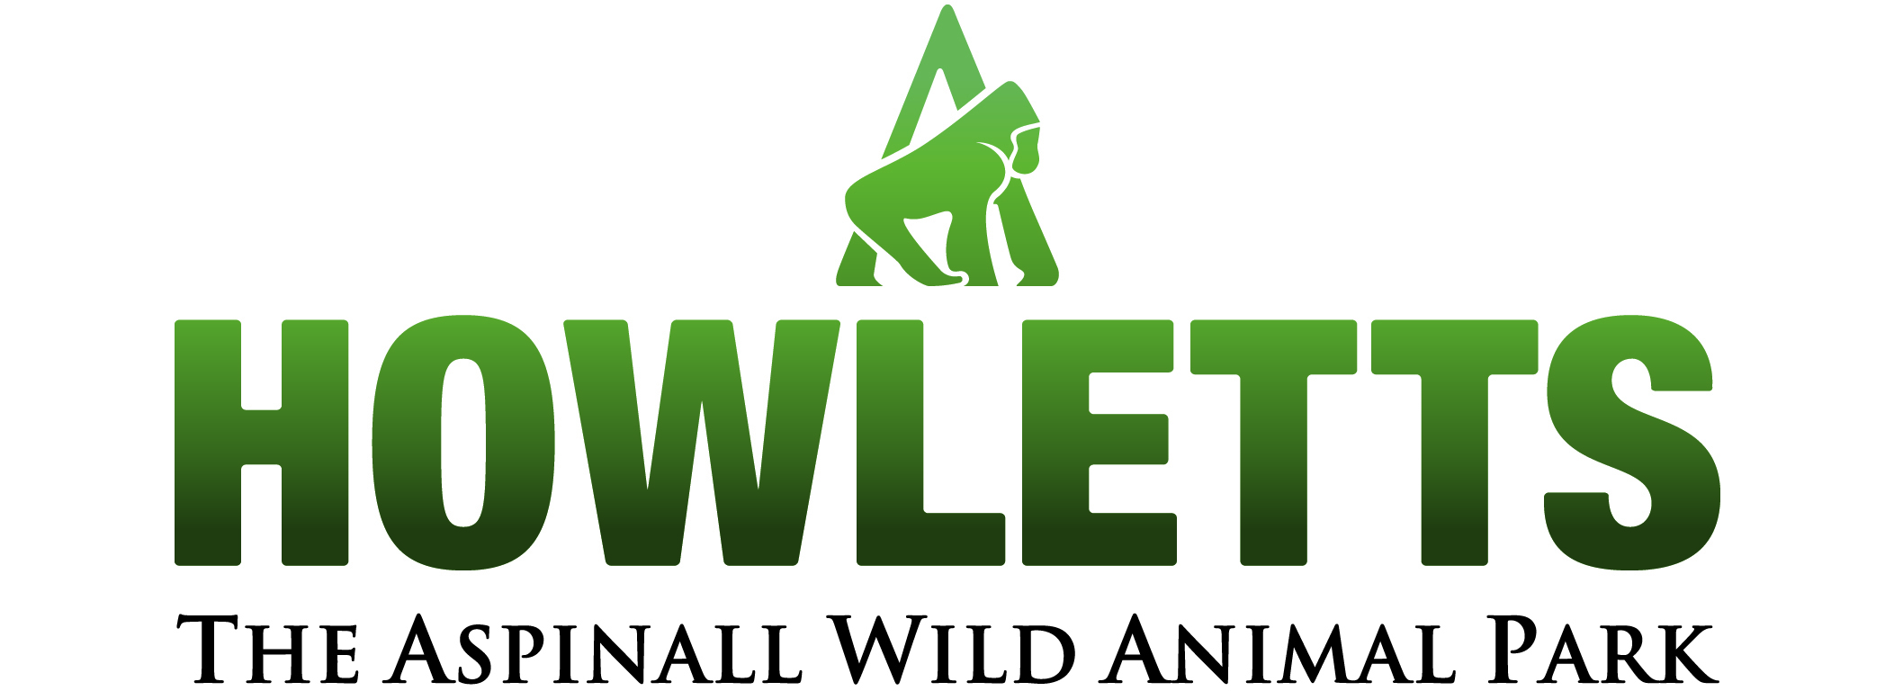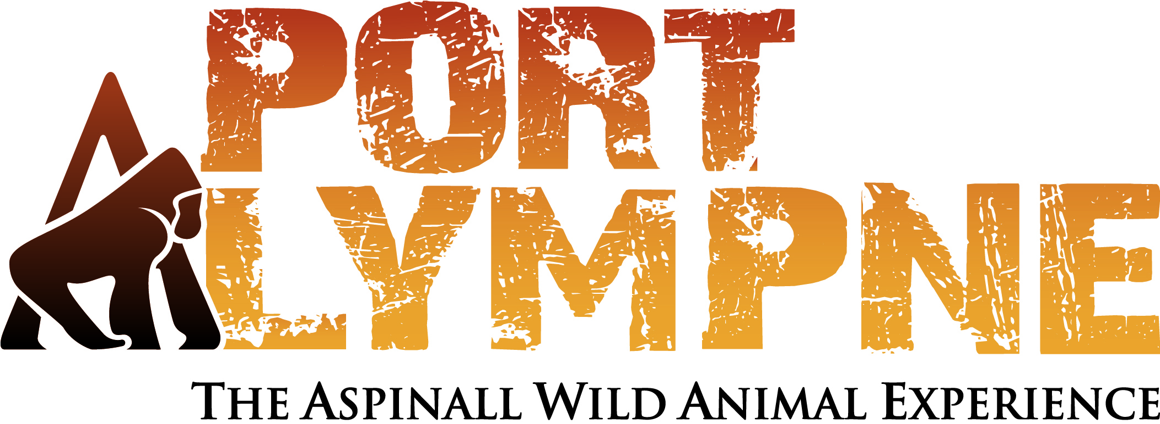

Enrichment and Research Internship (unpaid)

Howletts and Port Lympne are sister parks in Kent housing over 1000 animals from a range of species (primarily mammals). We have multiple-groups of many of these species, providing fantastic research opportunities. We are currently undertaking a long term project to provide easily accessible enrichment items to our keepers though enrichment workshops with the public. This is in order to continue to promote animal welfare, and we are working on plans to quantitatively assess this.
We are therefore looking for enthusiastic graduate students wanting to gain practical experience in zoo welfare and research for a 6month to 1year placement working between both parks.

The successful applicant will have the opportunity to run an extended research project, the results of which could be submitted to a research/enrichment conference, gain experience in zoo based research with a wide variety of species, gain experience in the organisation of professional workshops and conferences for keepers and students in collaboration with zoo professionals in the fields of enrichment and research. A chance to get involved in two conferences: the ‘Primate Society of GB Spring Meeting’ and the ‘UK and Ireland Regional Environmental Enrichment Conference’ which will be hosted by the parks in 2012.

We are looking for someone with a BSc in zoology, animal behaviour, psychology or similar qualification who has a passion for conservation and captive research. You will need a good knowledge of statistics programmes such as SPSS, have experience of data collection with various animal species, Good communication skills, a full clean driving license and your own transport and a flexible approach to working hours is essential.

Working three to four days a week which will include some weekends ideally we are looking for someone to start as soon as possible although applicants whose degree finishes in June will be considered.
Applicants will be short listed and must be available to attend an interview at Port Lympne during May. Please be aware that we are unable to offer accommodation with this internship.
Please apply by emailing a CV and covering letter to: Mark Kingston Jones - research@aspinallfoundation.org.

A full description of the internship placement is available upon request.

Closing date: 6th May 2011

