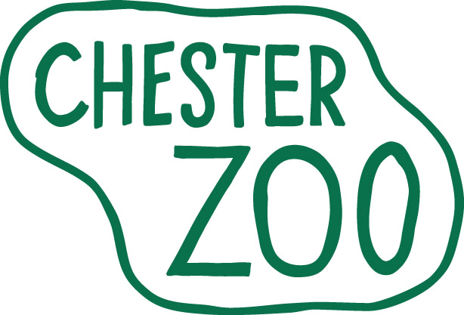
ONE YEAR INTERNSHIP (Botany and Horticulture)
Sept 2016 – Sept 2017

The North of England Zoological Society (Chester Zoo) is one of the UK’s leading Zoological Gardens, with many horticultural features, gardens, and greenhouses in our 125 acre site. As well as a diverse range of ornamental and naturalistic gardens and tropical houses, the Zoo cares for 5 National Plant Collections, including Nepenthes (Pitcher Plants) Pleurothallidinae orchids and 3 cactus taxa. The Zoo is also engaged in the conservation and propagation of several native plant species.
We are looking for highly committed, motivated individuals to join our Botany and Horticulture Department for 12 month work experience/internship placements within this unique scientific/conservation environment.

These placements are demanding but highly rewarding voluntary positions giving the opportunity to gain invaluable practical work experience.

The Internships:

- Maximum eleven months duration (plus four weeks holiday), commencing on Monday 12 September 2016 and finishing August/September 2017.

- Interns will be assigned to the Nursery Team; specialising in nursery practices, the Gardens Team; specialising in amenity horticulture; and the Projects Team, which (among other duties) carries out small landscape construction projects within the Zoo. Interns will normally spend four months with each team, although there is some flexibility to suit individual candidates’ preferences.

- A limited number of places may provide the opportunity to combine the Internship with a ‘Sandwich Year’ of a University Course. If applicable to you, please ensure this is made clear in Section 4 of your application form.

- Interns will receive on-the-job training in the cultivation of the species with which they work and training and instruction in the use of tools and equipment necessary to do the job. Working in the Gardens and Projects teams you will be mainly involved in the construction and maintenance of horticultural displays and animal enclosures. In the Nursery team you will grow and propagate a wide range of plants including rare, endangered, tropical and hardy plants for the gardens, our conservation work, animal enclosures, animal houses and for the educational division. Interns will be required to attend a series of monthly ‘Workshops’ which are arranged to teach other Zoological management topics including the basics of nutrition, collection planning, breeding programmes, in-situ conservation programmes, record keeping, enrichment etc.

- This is a full time and physically demanding position. Hours of work are from 7.00 am to 4.00 pm (Summer) and 8.00 am to 4.20 pm (Winter), working 5 days in seven, including 1:4 weekends, bank holidays etc. as rostered.

As we are a Registered Charity, funded entirely by visitor fees and donations, we regret we are unable to offer any wages or salary for the placement. We will provide a full uniform and luncheon vouchers for the days that you attend. No other financial benefits are offered. However, we do offer a comprehensive practical training covering a wide range of subjects, providing significant insight into the functioning of a successful and responsible botanical collection, the aim being to promote your future employability.

What we are looking for in our interns:

- You must currently be studying for, or have completed, a horticulture related course at Level 3 NVQ, HND or above.
- You must have a genuine interest in all aspects of horticulture and be empathetic to the mission of the Zoo.
- You must be able to work as an individual or as part of a team, with a reliable and conscientious attitude and good communication skills.
- Have the ability to financially support yourself for the entire length of the internship.

Interested?

Application forms can be obtained from the Chester Zoo Website www.chesterzoo.org. Please ensure you use the Botany & Horticulture One Year Internship Application Form and return it by post FAO ‘Penny Rudd’, The North of England Zoological Society, Caughall Road, Upton-by-Chester, CHESTER, CH2 1LH. For urgent and genuine queries only please contact Penny Rudd via email PennyR@chesterzoo.org. Interviews will be held for these positions in April and May 2016. Applicants from outside the UK will be offered Skype interviews but would be expected to fund their own travel and relocation costs if successful. Closing date: Friday 15 April 2016.

