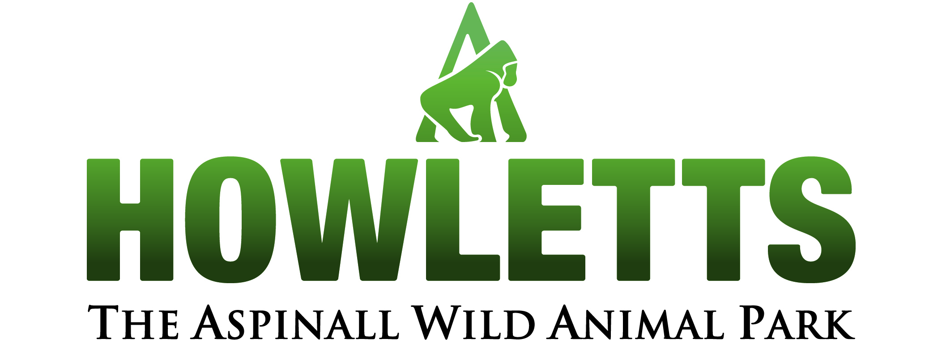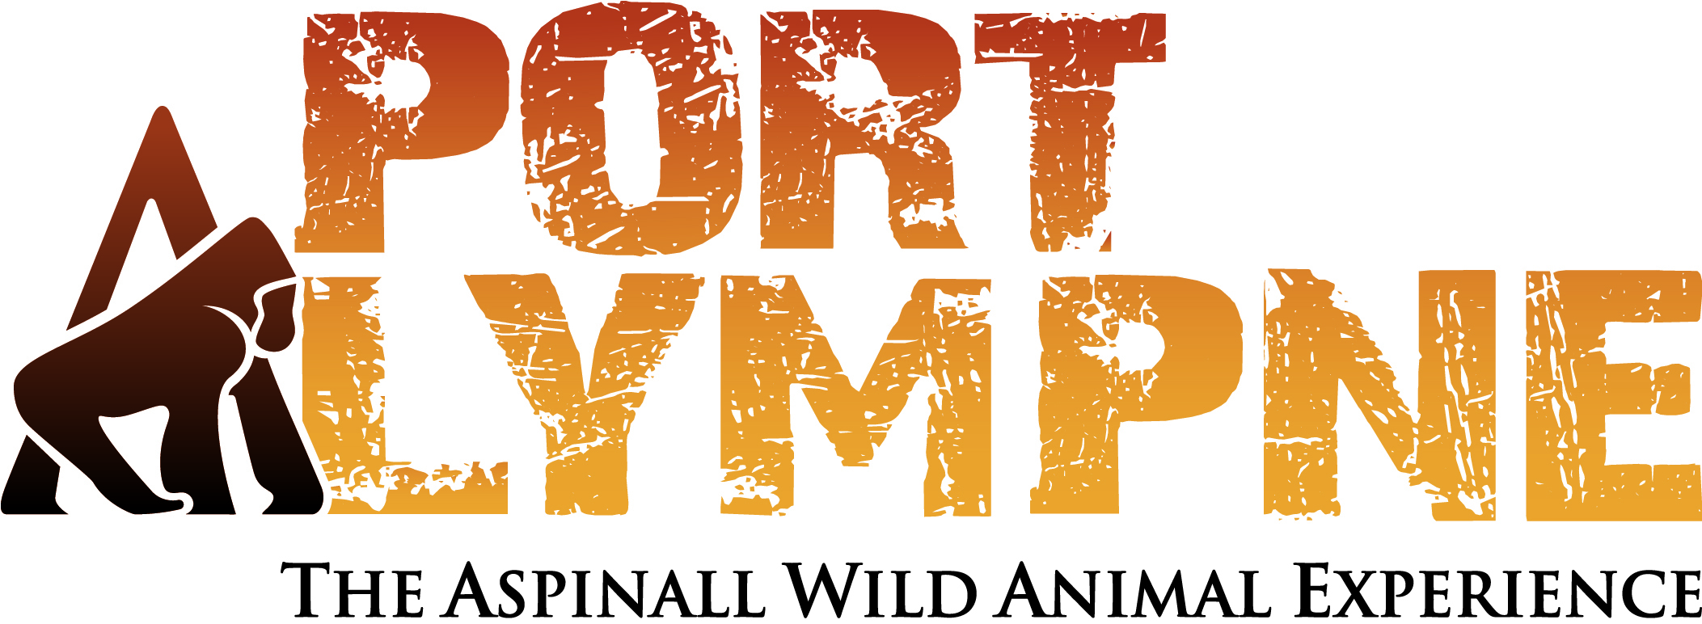

The Fifth Howletts and Port Lympne Student Environmental Enrichment Course (SEEC)

15th to 18th November 2010

Instructors: Mark Kingston Jones and Chris Hales

Due to the high demand for places and positive feedback, Howletts and Port Lympne Wild Animal Parks are pleased to announce their fifth student course on Environmental Enrichment to be run by Mark Kingston Jones and Chris Hales, in collaboration with keepers from both institutions. Mark has been involved in the animal welfare field since 2004. He now works at Howletts and Port Lympne as ‘Enrichment and Research Officer’, organising workshops, talks and working with keepers to design and implement enrichment ideas. In addition to running the previous Student Environmental Enrichment Courses, he has been involved in two Shape workshops, in the UK and Indonesia and is now the Shape-UK & Ireland events co-ordinator. As well as being an Honorary Research Fellow of the School of Anthropology and Conservation, University of Kent, he received two animal welfare awards for student research projects, and has presented 9 talks on topics relating to animal welfare at conferences, both nationally and internationally. Chris has been an instructor on three previous courses, having been a Keeper at Port Lympne for 12yrs, with experience working on every section with a multitude of taxa. He has a wide range of experience in the field of husbandry and enrichment specializing in carnivores and developing long term secondary enrichment to promote natural behaviours which he has presented at the 2010 REEC.

This course is designed specifically for college and university students (past and present) who do not currently work within a zoo setting, but are looking to do so as a career. Over 3½ days students will gain a background in animal welfare and enrichment, dealing with welfare needs of different species, as well as providing practical skills in designing, building and testing enrichment within the settings of both Howletts and Port Lympne Wild Animal Parks, in Kent. Our aim is to provide valuable experience and an overview of additional useful skills to a would-be keeper’s CV. Please note you must be 18 or over to attend this course.

This course is roughly split equally between lecture and practical components. Lecture topics include: Animal welfare, the 5 categories of enrichment, the enrichment framework, animal husbandry and learning, enclosure design and breaking into the zoo world. Additionally there will be Keeper lead talks and practicals involving working with carnivores, primates, ungulates, elephant management, in-situ conservation, rope splicing and fire hose weaving. The final day of the course will result in the application of all these principles as delegates are split into groups allowing you the opportunity to design, build and test enrichment with one of our animals from a selection of species.

Please note that delegates are required to provide their own lunches and can either bring their own or purchase food from the canteen. Information on discounted accommodation including dinner, bed and breakfast is available on request and the number of available places is limited, so please book early.

The workshop registration fee of £150 includes:
~ All workshop materials over the 3½ days.
~ Practical sessions.
~ Drinks and biscuits during the scheduled tea breaks.

For further information and to request a booking form please contact: Christine Dutfield on:
ccw@aspinallfoundation.org

Deadline for registered is the 31st of October 2010.

