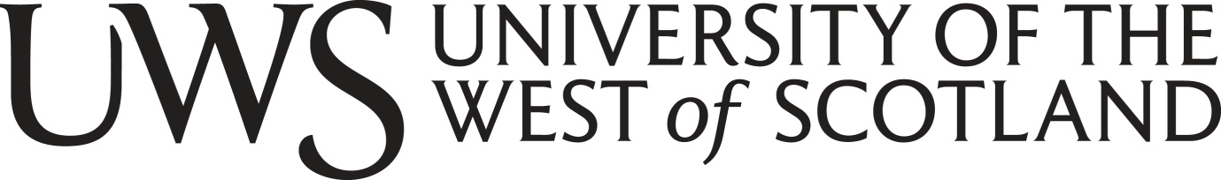
School of Education and Social Science

Participant Information Sheet

A Qualitative Study into the Classification of Great Apes as Persons.

You are being invited to take part in a research study. Before you decide, it is important for you to understand why the research is being done and what it will involve. Please take time to read the following information carefully and discuss it with others if you wish. Please ask me if there is anything that is not clear or if you would like more information. Take time to decide whether or not you wish to take part.

What is the purpose of this study?
The purpose of this study is to determine whether individuals who have worked with primates believe they should be granted personhood and the benefits and consequences of this. I am conducting this qualitative research study for my BA (Honours) Social Sciences dissertation.

Why have I been chosen?
You have been chosen to take part in this study because of your experience working with great apes. Either in a zoo or sanctuary setting or in an academic sense, in the field of primatology or primate conservation.

Do I have to take part?
It is up to you to decide whether or not to take part, it is a voluntary study. If you do decide to take part, you will be given this information sheet to keep and be asked to sign a consent form. If you decide to take part, you are still free to withdraw at any time, even after the interview has taken place, without giving a reason.

What will happen to me if I take part?
If you decide to take part in this study, you will be asked to fill in a consent form and send back to me. After I have received this, I will contact you in order to arrange an interview time. Due to the current situation, the interviews will take place over zoom, rather than face-to-face. During the interview you will be asked a series of questions regarding:
- Your work with primates
- The concept of personhood
- Great apes
- Your opinions on great ape personhood
- Your opinions on current laws and legislations
You can ask to skip any question and you do not have to provide an answer to any question you do not want to. The interview will last approximately an hour, but this will vary depending on how much you have to say but remember you can stop and withdraw at any time, without reason and your interview will be destroyed. The interview will be structured like a conversation and will be audio-recorded allowing me to create typed transcripts after the interview has taken place. This information will not be used for anything other than as research for my dissertation.

What will happen to information I provide?
Overall, all the information provides will be used for dissertation purposes only. However, if any information is disclosed about the mistreatment or abuse of animals, this will not be kept confidential.

What are the possible disadvantages and risks of taking part?
Based on the UWS Ethics Committee guidance, I do not believe you are at any strong risks due to the fact I am not asking you any questions that would be classed as sensitive information. However, if based on what I have said I will ask you, you feel you are unable to take part in this study, thank you for considering anyway. If after starting the interview, you wish to withdraw this is completely acceptable and your choice.

What are the possible benefits of taking part?
A benefit of taking part in this study is your responses will be used to form an in-depth understanding of whether great apes should be granted personhood.

Data Protection Privacy Notice

The data controller for this project will be University of the West of Scotland (UWS). The UWS Data Protection Office provides oversight of UWS activities involving the processing of personal data and can be contacted at dataprotection@uws.ac.uk. UWS’s Data Protection Officer is Emma Cockrow and can be contacted at dataprotection@uws.ac.uk.

Your personal data will be processed so long as it is required for the research project. If we are able to anonymise or pseudonymise the personal data, you provide we will undertake this and will endeavour to minimise the processing of personal data wherever possible. You will be completely anonymous. I will not ask you for your name and you will be randomly allocated a participant number. If you choose to withdraw at any time after the interview has begun, you can contact me with this participant number, and I will be able to destroy your information. As this interview will take place over zoom, you are more than welcome to keep your camera off further keeping your anonymity. This is completely your choice. You will be asked the nature of your job, but you will be not be asked for specific titles or place of work. You will simply be asked if you work in a zoo, sanctuary or in primate conservation and to give a brief explanation of this role. I will not be able to trace you from this information. The last date for withdrawing is the 20th March 2021, as the dissertation deadline is the 24th April 2021.

If you are concerned about how your personal data is being processed, please contact UWS in the first instance at dataprotection@uws.ac.uk. If you remain unsatisfied, you may wish to contact the Information Commissioner’s Office (ICO). Contact details, and details of data subject rights, are available on the ICO website at: https://ico.org.uk/for-organisations/data-protection-reform/overview-of-the-gdpr/individuals-rights/

What will happen to the results of the research study?
The results of this participation in the study will not be published.

Who has reviewed the study?
ESS Ethics Committee

Contact for further information

If you require any further information please contact:
Researcher:
Name: Charlotte O’Neill
University of the West of Scotland,
Technology Avenue,
Blantyre,
G72 0LH
UK
Telephone: 07990760418
E-mail address: B00338473@studentmail.uws.ac.uk

Research Supervisor:
Name: Dr Nicolas Jenkins
University of the West of Scotland,
Technology Avenue,
Blantyre,
G72 0LH
UK
E-mail address: nick.jenkins@uws.ac.uk

Thank you for taking part in this study.

