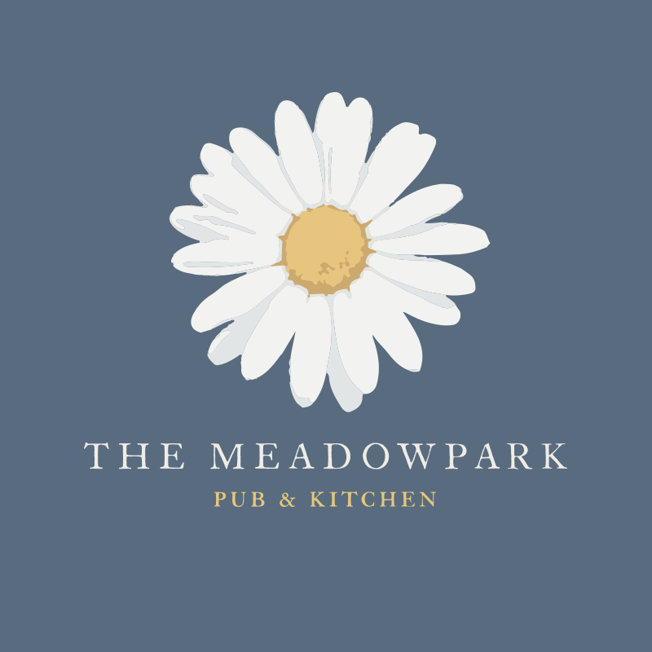

STARTERS

SOUP OF THE DAY (V)
with warm artisan bread

HAM HOUGH TERRINE
Artisan bread, salad, parsley, chutney

HAGGIS SPRING ROLLS (V*)
Smoked applewood, homemade chutney

MAINS

FALLENINCH STEAK PIE
Seasonal veg and chunky chips

SUNBLUSH RISOTTO (V)
Sunblush tomato, basil

DEVILS CHICKEN SUPREME (GF)
Lemon and chilli marinated chicken, sour cream crushed potato, sautéed greens

DESSERTS

ESPRESSO CRÈME BRULEE (GF*)
Shortbread

STICKY TOFFEE PUDDING
Vanilla ice cream, toffee sauce

CHEESECAKE OF THE DAY

2 courses £18/3 courses £22

(V*) Vegetarian option available. Please inform upon ordering.
(V) Vegetarian
(GF) Gluten Free
(GF*) Gluten Free option available

